Migration – Module List
- Company | Leviotto
- User | Leviotto
- Contacts
- HR / Employees | Leviotto
- Inventory & Products
  - Product Category, Uom
  - Product, Variants | Leviotto or Null
  - Packages
  - Stock Location
  - Stock(Quant) | Leviotto
  - Stock Move & Move line
  - Stock Valuation Layer
- Expenses
- Accounting
  - Account Move | Leviotto
  - Account Move Line | Leviotto
  - Account Payments | Leviotto
  - PDC Account Payments | Leviotto
  - Payment Terms | Leviotto
  - Chart of Accounts | Leviotto
  - Taxes | Leviotto
  - Journals | Leviotto

Server DB Link
http://5.195.111.211:1706/

Step 1 : Install Required Module
- stock account extend (raise problem of not save configuration)
- community_home_screen
- -u res_area
- stock
- purchase_orders_customization
- profit_and_loss_report
- product_customization
- package_transfer_details
- package_catalogue
- sale_management
- leviotto_sales_return
- sale_order_customization
- sale_margin
- shop_customization
- stock_barcode
- stock_barcode_extended
- om_account_accountant
- discount_amount
- customer_post_dated_cheque_app
- invoice_customisations first set "Fiscal Localization" then install it.
- multi_product_creation
- generate_seq_for_products
- database_migration
- execute_python_code

Step 2 : Connect Database
Local system

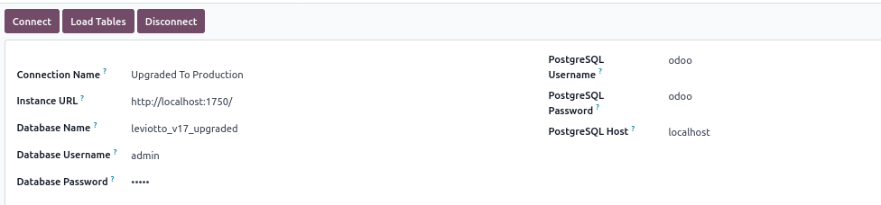
Server
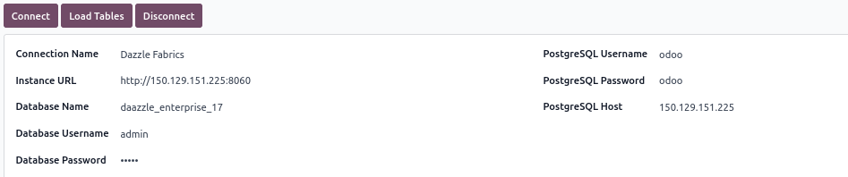
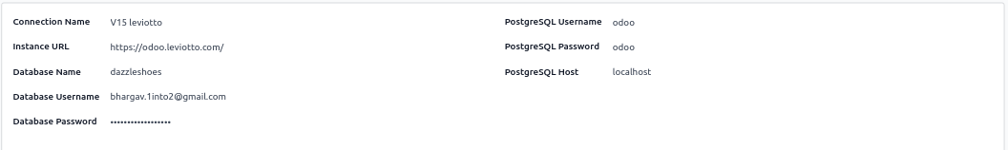

Note : Change Upgraded Database user and password of set admin , admin.

Migrate Matched Fields With Query
- Normale Fields
Migrate Relational Fields
- O2M Fields
Migrate Related Table’s Fields
- M2M Fields

Step 3 : Company

if old_table_name == 'res_company':
cursor.execute(f"SELECT {old_field_names} FROM {old_table_name} WHERE id = 2;")
rows = cursor.fetchall()
else:
cursor.execute(f"SELECT {old_field_names} FROM {old_table_name};")
rows = cursor.fetchall()

- update res_company set old_id = 2 where id = 1;

- res_currency_rate Empty
- update res_currency set old_id = 127 where id = 129;

- Company Favicon : No Field

- Street, City, State, Zip, Logo : Related to Partner

Step 4 : Contacts

- Migrate model : res_partner_category

UPDATE res_partner_category
SET name = jsonb_build_object(
'en_US',
REPLACE(name ->> 'en_US', '''', '"')::jsonb ->> 'en_US'
)
WHERE (name ->> 'en_US') LIKE '%''en_US''%';

- update res_partner_title set old_id = id;
- update res_partner_industry set old_id = id;
- update res_country set old_id = id;
- update res_country_state set old_id = id;

- update res_country_group set old_id = 1 where id = 1;
- update res_country_group set old_id = 2 where id = 2;
- update res_country_group set old_id = 3 where id = 3;
- update res_country_group set old_id = 4 where id = 4;
- update res_country_group set old_id = 5 where id = 7;

- update res_partner set old_id = 1738 where id = 1;
- update res_partner set old_id = 2 where id = 2;
- update res_partner set old_id = 3 where id = 3;
- update res_partner set old_id = 4 where id = 4;
- update res_partner set old_id = 5 where id = 5;
- update res_partner set old_id = 6 where id = 6;

- update crm_team set old_id = id;

- update res_bank set old_id = id;

- Migrate all Normal Fields : res_partner

- Migrate model : res_partner_bank

- Migrate partner Category M2M.
- res_partner_res_partner_category_rel : Not migrate when opening this table .
- Select id and category_id, then click Migrate Relational Fields

- update account_payment_term set old_id = id;
- Migrate : account_payment_term
  - skipp field: early_pay_discount_computation

UPDATE account_payment_term
SET name = jsonb_build_object(
'en_US',
REPLACE(name ->> 'en_US', '''', '"')::jsonb ->> 'en_US'
)
WHERE (name ->> 'en_US') LIKE '%''en_US''%';

- update account_payment_term_line set old_id = id;
- DELETE FROM account_payment_term_line;
- Migrate : account_payment_term_line

- property_payment_term_id (Hold)
  - Contact name for check payment term : ABC Shaklan Supermarket

- property_supplier_payment_term_id (Hold)
  - Contact name for check payment term : ABDUL REHMAN DIIBOUTY

- property_account_receivable_id
- property_account_payable_id
  - Migrate both using xmlrpc script

- Migrate : res_partner
- Country id
- User id (salesperson)
- Sales team

Step 5 : Users

if old_table_name == 'res_users':
cursor_old.execute(f"SELECT {old_field_names} FROM {old_table_name} WHERE company_id = 2")
rows = cursor_old.fetchall()
else:
cursor_old.execute(f"SELECT {old_field_names} FROM {old_table_name}")
rows = cursor_old.fetchall()

- update res_users set old_id = id;
- MIgrate : res_users

Need to get Dazzle user : Thamees (old_id : 6) for HR Expense Sheet

Need To add Dazzle User :
Thamees (old_id : 6)
Aakqer8 Business Solution (old_id : 46)
Rijas (old_id : 52)
Its Employe :
Administrator (old_id : 1)
Thamees (old_id : 15) its already in leviotto company
Aakqer8 Business Solution (old_id : 35) its already in leviotto company
Rijas (old_id : 40)

<field name="company_ids"/>
Set leviotto company of all user

Step 6 : Employee

if old_table_name == 'res_company':
cursor.execute(f"SELECT {old_field_names} FROM {old_table_name} WHERE id = 2;")
rows = cursor.fetchall()
elif old_table_name == 'hr_employee':
cursor.execute(f"SELECT {old_field_names} FROM {old_table_name} WHERE company_id = 2 OR id IN (15, 36);")
rows = cursor.fetchall()
else:
cursor.execute(f"SELECT {old_field_names} FROM {old_table_name};")
rows = cursor.fetchall()

- update hr_employee set old_id = id;
- update hr_contract_type set old_id = id;

- update hr_department set old_id = id;

- Migrate : hr_job

UPDATE hr_job
SET name = jsonb_build_object(
'en_US',
REPLACE(name ->> 'en_US', '''', '"')::jsonb ->> 'en_US'
)
WHERE (name ->> 'en_US') LIKE '%''en_US''%';

- update hr_departure_reason set old_id = id;

—
UPDATE hr_employee
SET company_id = NULL
WHERE id != 1;

DELETE FROM hr_employee
WHERE id <> 1;
—

- update resource_calendar set old_id = id;

- The private address was not migrated because v15 does not have the same fields.

- Migrate : hr_employee
  - Manager
  - Expense
  - Skipp : Lang, Gander

- This fields are no need to set, in old database have not set its records.
  - hr.departure.reason, resource.resource, hr.work.location, hr.department

- Manually update timezone in employe

- Note : Employee safa has no need to add its user
  - First migrate with selecting user id
  - Then update its parent record
  - Then migrate without selecting user id
  - Then update its parent record
  - Successfully safa employees migrate

Step 7 : Inventory - Product

- Enable variant and UoM settings.

- update uom_category set old_id = id;
- Migrate uom_category

UPDATE uom_category
SET name = jsonb_build_object(
'en_US',
REPLACE(name ->> 'en_US', '''', '"')::jsonb ->> 'en_US'
)
WHERE (name ->> 'en_US') LIKE '%''en_US''%';

- For Create Date of uom_category
  - Create date using create method, no need to get code changes, select random field and click button.

- update uom_uom set old_id = id;
- Migrate uom_uom

UPDATE uom_uom
SET name = jsonb_build_object(
'en_US',
REPLACE(name ->> 'en_US', '''', '"')::jsonb ->> 'en_US'
)
WHERE (name ->> 'en_US') LIKE '%''en_US''%';

- update product_removal set old_id = id;

- update product_category set old_id = id;
- Migrate : product_category
  - First time without selecting parent_id
  - Second time select parent_id

- For Create Date of product_category
  - Create date using create method, no need to get code changes, select random field and click button.

- For : property_valuation

if current_table == "product.category" and "property_valuation" not in record_data_to_update:
record_data_to_update["property_valuation"] = "real_time"

existing_record.write(record_data_to_update)
self.env.cr.commit()
_logger.info(
f"Record with old_id {old_id_value} updated successfully."
)

if current_table == "product.category" and "property_valuation" not in record_data:
record_data["property_valuation"] = "real_time"

self.env[current_table].sudo().create(record_data)
self.env.cr.commit()
_logger.info(
f"New record with old_id======___________========----- {old_id_value} created successfully."
)

–
Old Category ID 1 -> Valuation: manual_periodic -> New Category ID 1
Old Category ID 2 -> Valuation: manual_periodic -> New Category ID 2
Old Category ID 3 -> Valuation: manual_periodic -> New Category ID 3
Old Category ID 4 -> Valuation: manual_periodic -> New Category ID 91
Old Category ID 224 -> Valuation: manual_periodic -> New Category ID 129
Old Category ID 223 -> Valuation: manual_periodic -> New Category ID 128
Old Category ID 211 -> Valuation: manual_periodic -> New Category ID 113
Old Category ID 216 -> Valuation: manual_periodic -> New Category ID 126
Old Category ID 212 -> Valuation: manual_periodic -> New Category ID 114
–

- For : property_cost_method

if current_table == "product.category" and "property_cost_method" not in record_data_to_update:
record_data_to_update["property_cost_method"] = "average"

if current_table == "product.category" and "property_cost_method" not in record_data:
record_data["property_cost_method"] = "average"

- For : Income, Expense, Stock Valuation, Stock Journal, Stock Input, Stock Output Account Of Product Category Set Manually using Paython Executing Script :

categories = self.env['product.category'].search([])

income_account = self.env['account.account'].search([('code','=',500001)],limit=1)
expense_account = self.env['account.account'].search([('code','=',400001)],limit=1)
stock_valuation_account = self.env['account.account'].search([('code','=',110100)],limit=1)
stock_input_account = self.env['account.account'].search([('code','=',110200)],limit=1)
stock_output_account = self.env['account.account'].search([('code','=',110300)],limit=1)
stock_journal = self.env['account.journal'].search([('old_id','=',20)],limit=1)

for rec in categories:
rec.property_account_income_categ_id = income_account
rec.property_account_expense_categ_id = expense_account
rec.property_stock_valuation_account_id = stock_valuation_account
rec.property_stock_account_input_categ_id = stock_input_account
rec.property_stock_account_output_categ_id = stock_output_account
rec.property_stock_journal = stock_journal

select count(*) from product_template where company_id = 2 or company_id is null;

if old_table_name == 'res_company':
cursor.execute(f"SELECT {old_field_names} FROM {old_table_name} WHERE id = 2;")
rows = cursor.fetchall()
elif old_table_name == 'hr_employee':
cursor.execute(f"SELECT {old_field_names} FROM {old_table_name} WHERE company_id = 2 OR id IN (15, 36);")
rows = cursor.fetchall()
elif old_table_name == 'product_template':
cursor.execute(f"SELECT {old_field_names} FROM {old_table_name} WHERE company_id = 2 OR company_id Is Null;")
rows = cursor.fetchall()
else:
cursor.execute(f"SELECT {old_field_names} FROM {old_table_name};")
rows = cursor.fetchall()

- update product_template set old_id = id;
- Migrate product_template
  - Skipp : invoice_policy, service_type, purchase_method, expense_policy, list_price

def update_product_name(self):
product_id = self.env['product.template'].search([])
if product_id:
for product in product_id:
if isinstance(product.name, str) and product.name.startswith("{") and product.name.endswith("}"):
try:
import ast
name_dict = ast.literal_eval(product.name)
if 'en_US' in name_dict:
product.name = name_dict['en_US']
_logger.info(f"product name update for {product.name}")
except Exception as e:
_logger.error(f"Failed to parse product name for {product.id}: {e}")

- delete from product_product;

SELECT COUNT(*)
FROM product_product AS pp
JOIN product_template AS pt ON pp.product_tmpl_id = pt.id
WHERE pt.company_id = 2 OR pt.company_id IS NULL;

if old_table_name == 'res_users':
cursor_old.execute(f"SELECT {old_field_names} FROM {old_table_name} WHERE company_id = 2;")
rows = cursor_old.fetchall()
elif old_table_name == 'product_product':
# Prefix all field names with 'pp.' to avoid ambiguous column names
prefixed_field_names = ", ".join([f"pp.{f.strip()}" for f in old_field_names.split(",")])
cursor_old.execute(f"""
SELECT {prefixed_field_names}
FROM {old_table_name} pp
JOIN product_template pt ON pp.product_tmpl_id = pt.id
WHERE pt.company_id = 2 OR pt.company_id IS NULL;
""")
rows = cursor_old.fetchall()
else:
cursor_old.execute(f"SELECT {old_field_names} FROM {old_table_name}")
rows = cursor_old.fetchall()

- Migrate : product_product (must select product template id)
  - Skipp : list_price

For product template internal note description:

UPDATE product_template
SET description = jsonb_build_object(
'en_US',
REGEXP_REPLACE(
REGEXP_REPLACE(
description ->> 'en_US',
'^<p>\{''en_US'': ''</p>',
'',
'g'
),
'''\}$',
'',
'g'
)
)
WHERE description ->> 'en_US' ~ '<p>\{''en_US'': ''</p>';
- For : Product Customer Taxes and Vendor Taxes

elif current_table_name in ["product_supplier_taxes_rel", "product_taxes_rel"]:
for row in rows:
old_prod_id, old_tax_id = row

# Get new product_template ID using old_id
cursor_current.execute("SELECT id FROM product_template WHERE old_id = %s", (old_prod_id,))
result = cursor_current.fetchone()
new_prod_id = result[0] if result else None

# Get new account_tax ID using old_id
cursor_current.execute("SELECT id FROM account_tax WHERE old_id = %s", (old_tax_id,))
result = cursor_current.fetchone()
new_tax_id = result[0] if result else None

# Skip if either mapping not found
if not new_prod_id or not new_tax_id:
_logger.warning(
f"Skipping row: prod_id or tax_id not found for old_ids: {old_prod_id}, {old_tax_id}")
continue

# Check if the record already exists to prevent duplicates
cursor_current.execute(
f"""
SELECT 1 FROM {current_table_name}
WHERE prod_id = %s AND tax_id = %s
""",
(new_prod_id, new_tax_id)
)
if cursor_current.fetchone():
_logger.info(
f"Relation already exists for prod_id={new_prod_id}, tax_id={new_tax_id}. Skipping.")
continue

# Insert the record
cursor_current.execute(
f"INSERT INTO {current_table_name} (prod_id, tax_id) VALUES (%s, %s)",
(new_prod_id, new_tax_id)
)
_logger.info(f"Inserted new relation: prod_id={new_prod_id}, tax_id={new_tax_id}")

- Open M2M Table and Migrate it.

- product_supplier_taxes_rel
- product_taxes_rel

Attribute

- product_attribute
  - value_ids O2M : model - product_attribute_value
  - attribute_line_ids O2M : model - product.template.attribute.line

- product_attribute_value
  - attribute_id M2O : model - product_attribute
  - pav_attribute_line_ids M2M : model - product.template.attribute.line

- product_template_attribute_line
  - value_ids M2M : model - product_attribute_value (M2M table name : product_attribute_value_product_template_attribute_line_rel)
  - attribute_id M2O : model - product_attribute
  - product_tmpl_id M2O : model - product_template
  - product_template_value_ids O2M : model - product.template.attribute.value

- product_template_attribute_value
  - ptav_product_variant_ids M2M : model - product.product
  - attribute_line_id M2O : model - product.template.attribute.line
  - product_attribute_value_id M2O : model - product.attribute.value
  - product_tmpl_id M2O : model - product_template
  - attribute_id M2O : model - product_attribute
  - exclude_for O2M : model - product.template.attribute.exclusion

- product_template_attribute_exclusion
  - value_ids M2M : model - product.template.attribute.value
  - product_tmpl_id M2O : model - product_template
  - product_template_attribute_value_id M2O : model - product.template.attribute.value

- product_template
  - attribute_line_ids O2M : model - product.template.attribute.line
  - valid_product_template_attribute_line_ids M2M : model - product.template.attribute.line

- product_product
  - attribute_line_ids O2M : model - product.template.attribute.line
  - valid_product_template_attribute_line_ids M2M : model - product.template.attribute.line
  - product_template_attribute_value_ids M2M : model - product.template.attribute.value
  - product_template_variant_value_ids M2M : model - product.template.attribute.value

- Migrate : product_attribute

UPDATE product_attribute
SET name = jsonb_build_object(
'en_US',
REPLACE(name ->> 'en_US', '''', '"')::jsonb ->> 'en_US'
)
WHERE (name ->> 'en_US') LIKE '%''en_US''%';

- Migrate : product_attribute_value

UPDATE product_attribute_value
SET name = jsonb_build_object(
'en_US',
REPLACE(name ->> 'en_US', '''', '"')::jsonb ->> 'en_US'
)
WHERE (name ->> 'en_US') LIKE '%''en_US''%';

if old_table_name == 'res_company':
cursor.execute(f"SELECT {old_field_names} FROM {old_table_name} WHERE id = 2;")
rows = cursor.fetchall()
elif old_table_name == 'hr_employee':
cursor.execute(f"SELECT {old_field_names} FROM {old_table_name} WHERE company_id = 2 OR id IN (15, 36);")
rows = cursor.fetchall()
elif old_table_name == 'product_template':
cursor.execute(f"SELECT {old_field_names} FROM {old_table_name} WHERE company_id = 2 OR company_id Is Null;")
rows = cursor.fetchall()
elif old_table_name == 'product_template_attribute_line':
template_records = self.env['product.template'].search([('old_id', '!=', False)])
old_template_ids = [tmpl.old_id for tmpl in template_records if tmpl.old_id]
id_list_str = ", ".join(map(str, old_template_ids))
cursor.execute(f"SELECT {old_field_names} FROM {old_table_name} WHERE product_tmpl_id In ({id_list_str});")
rows = cursor.fetchall()
else:
cursor.execute(f"SELECT {old_field_names} FROM {old_table_name};")
rows = cursor.fetchall()

- Migrate : product_template_attribute_line
  - Select normal filed, attribute_id, product_tmpl_id : migrate it

- Migrate : product_attribute_value
  - Select id, pav_attribute_line_ids : migrate it clicking “Migrate Relational Fields” button

if old_table_name == 'res_company':
cursor.execute(f"SELECT {old_field_names} FROM {old_table_name} WHERE id = 2;")
rows = cursor.fetchall()
elif old_table_name == 'hr_employee':
cursor.execute(f"SELECT {old_field_names} FROM {old_table_name} WHERE company_id = 2 OR id IN (15, 36);")
rows = cursor.fetchall()
elif old_table_name == 'product_template':
cursor.execute(f"SELECT {old_field_names} FROM {old_table_name} WHERE company_id = 2 OR company_id Is Null;")
rows = cursor.fetchall()
elif old_table_name == 'product_template_attribute_line':
template_records = self.env['product.template'].search([('old_id', '!=', False)])
old_template_ids = [tmpl.old_id for tmpl in template_records if tmpl.old_id]
id_list_str = ", ".join(map(str, old_template_ids))
cursor.execute(f"SELECT {old_field_names} FROM {old_table_name} WHERE product_tmpl_id In ({id_list_str});")
rows = cursor.fetchall()
elif old_table_name == 'product_template_attribute_value':
attribute_lines = self.env['product.template.attribute.line'].search([('old_id','!=', False)])
old_attribute_lines_ids = [atr_val.old_id for atr_val in attribute_lines if atr_val.old_id]
attribute_lines_id_list_str = ", ".join(map(str, old_attribute_lines_ids))
cursor.execute(
f"SELECT {old_field_names} FROM {old_table_name} WHERE attribute_line_id In ({attribute_lines_id_list_str});")
rows = cursor.fetchall()
else:
cursor.execute(f"SELECT {old_field_names} FROM {old_table_name};")
rows = cursor.fetchall()

- Migrate : product_template_attribute_value
  - Select normal fields, attribute_line_id, product_attribute_value_id, product_tmpl_id, attribute_id : migrate it

- Migrate : product_product
  - id, product_template_variant_value_ids : migrate it clicking “Migrate Relational Fields” button

- Migrate : product_template
  - Migrate fields : invoice_policy, uom_po_id, uom_id, categ_id
  - responsible_id not stored in db. pending to migrate

- Migrate : product_supplierinfo

Stock Quant : Next Time

update stock_location set old_id = 1 where id = 1;
update stock_location set old_id = 2 where id = 2;
update stock_location set old_id = 3 where id = 3;
update stock_location set old_id = 4 where id = 4;
update stock_location set old_id = 5 where id = 5;

update stock_location set old_id = 6 where id = 6;

update stock_location set old_id = 40 where id = 7;
update stock_location set old_id = 41 where id = 8;

update stock_location set old_id = 37 where id = 14;
update stock_location set old_id = 38 where id = 15;
update stock_location set old_id = 39 where id = 16;

- Migrate : stock_quant_package (Migrate all Packages because only package available of leviotto company)
  - No migrate package_type_id
  - Second time need to migrate company_id, location_id
  - Pending package transfer smart button

if old_table_name == 'res_users':
cursor_old.execute(f"SELECT {old_field_names} FROM {old_table_name} WHERE company_id = 2;")
rows = cursor_old.fetchall()
elif old_table_name == 'product_product':
prefixed_field_names = ", ".join([f"pp.{f.strip()}" for f in old_field_names.split(",")])
cursor_old.execute(f"""
SELECT {prefixed_field_names}
FROM {old_table_name} pp
JOIN product_template pt ON pp.product_tmpl_id = pt.id
WHERE pt.company_id = 2 OR pt.company_id IS NULL;
""")
rows = cursor_old.fetchall()
elif old_table_name == 'stock_quant':
cursor_old.execute(f"SELECT {old_field_names} FROM {old_table_name} WHERE company_id = 2;")
rows = cursor_old.fetchall()
else:
cursor_old.execute(f"SELECT {old_field_names} FROM {old_table_name}")
rows = cursor_old.fetchall()

- Migrate : stock.quant
  - User id verify why not found.

select count(*) from stock_quant_package;

select count(*) from stock_quant where company_id =2;

SELECT SUM(quantity) AS total_quantity
FROM stock_quant
WHERE company_id = 2;

Step 8 : Expense

Account Configuration

- update mail_activity_type set old_id = 1 where id = 1;
- update mail_activity_type set old_id = 2 where id = 2;
- update mail_activity_type set old_id = 3 where id = 3;
- update mail_activity_type set old_id = 4 where id = 4;
- update mail_activity_type set old_id = 5 where id = 5;
- update mail_activity_type set old_id = 9 where id = 7;

elif old_table_name == 'account_account':
cursor.execute(f"SELECT {old_field_names} FROM {old_table_name} WHERE company_id = 2;")
rows = cursor.fetchall()

- delete from account_journal;
- delete from account_account;
- Migrate : account_account
  - account_group filed no need to migrate its Empty

UPDATE account_account
SET name = jsonb_build_object(
'en_US',
REPLACE(name ->> 'en_US', '''', '"')::jsonb ->> 'en_US'
)
WHERE (name ->> 'en_US') LIKE '%''en_US''%';

elif old_table_name == 'account_tax':
cursor.execute(f"SELECT {old_field_names} FROM {old_table_name} WHERE company_id = 2;")
rows = cursor.fetchall()

- delete from account_tax;
- delete from account_fiscal_position;

update account_tax_group set old_id = 2 where id = 1;
update account_tax_group set old_id = 3 where id = 2;
update account_tax_group set old_id = 4 where id = 3;

- Migrate : account_tax_group

UPDATE account_tax_group
SET name = jsonb_build_object(
'en_US',
REPLACE(name ->> 'en_US', '''', '"')::jsonb ->> 'en_US'
)
WHERE (name ->> 'en_US') LIKE '%''en_US''%';

- Migrate : account_tax
  - Skip: tax_scope

UPDATE account_tax
SET name = jsonb_build_object(
'en_US',
REPLACE(name ->> 'en_US', '''', '"')::jsonb ->> 'en_US'
)
WHERE (name ->> 'en_US') LIKE '%''en_US''%';

UPDATE account_tax
SET invoice_label = jsonb_build_object(
'en_US',
REPLACE(invoice_label ->> 'en_US', '''', '"')::jsonb ->> 'en_US'
)
WHERE (invoice_label ->> 'en_US') LIKE '%''en_US''%';

update account_account_tag set old_id = id;

- Migrate : account_account_tag

UPDATE account_account_tag
SET name = jsonb_build_object(
'en_US',
REPLACE(name ->> 'en_US', '''', '"')::jsonb ->> 'en_US'
)
WHERE (name ->> 'en_US') LIKE '%''en_US''%';

elif old_table_name == 'account_tax_repartition_line':
cursor.execute(f"SELECT {old_field_names} FROM {old_table_name} WHERE company_id = 2;")
rows = cursor.fetchall()

- delete from account_tax_repartition_line;

- Migrate : account_tax_repartition_line
  - Select normal field, m2o fields - migrate it
  - Second time migrate Select : id, tag_ids : migrate it clicking “Migrate Relational Fields” button

elif old_table_name == 'account_journal':
cursor.execute(f"SELECT {old_field_names} FROM {old_table_name} WHERE company_id = 2;")
rows = cursor.fetchall()

if current_table == "account.journal" and old_id_value in [15, 16]:
for key, value in record_data.items():
if isinstance(value, dict):
record_data[key] = value.get("en_US") or next(iter(value.values()),
None)
_logger.warning(
f"Converted dict to string for field '{key}' (old_id={old_id_value})"
)

- Migrate : account_journal
  - Skip : bank_statements_source

UPDATE account_journal
SET name = jsonb_build_object(
'en_US',
REPLACE(name ->> 'en_US', '''', '"')::jsonb ->> 'en_US'
)
WHERE (name ->> 'en_US') LIKE '%''en_US''%';

- After migrate account journal set its old_id and id properly to check in view
  - update account_journal set old_id = 15 where id = 27;
  - update account_journal set old_id = 16 where id = 28;

—
- Migrate : mail_alias_domain

Remove Customer and Vendor journal Alias then delete it.
delete from mail_alias;

- Migrate : mail_alias
—

update account_payment_method set old_id = id;

- Migrate : account_payment_method

UPDATE account_payment_method
SET name = jsonb_build_object(
'en_US',
REPLACE(name ->> 'en_US', '''', '"')::jsonb ->> 'en_US'
)
WHERE (name ->> 'en_US') LIKE '%''en_US''%';

update payment_provider set old_id = 1 where id = 1;
update payment_provider set old_id = 15 where id = 2;
update payment_provider set old_id = 16 where id = 3;
update payment_provider set old_id = 3 where id = 4;
update payment_provider set old_id = 4 where id = 5;
update payment_provider set old_id = 13 where id = 6;
update payment_provider set old_id = 17 where id = 7;
update payment_provider set old_id = 18 where id = 8;
update payment_provider set old_id = 5 where id = 9;
update payment_provider set old_id = 7 where id = 10;
update payment_provider set old_id = 19 where id = 11;
update payment_provider set old_id = 10 where id = 12;
update payment_provider set old_id = 11 where id = 13;
update payment_provider set old_id = 12 where id = 14;
update payment_provider set old_id = 14 where id = 15;
update payment_provider set old_id = 20 where id = 16;

delete from account_payment_method_line;

- Migrate : account_payment_method_line
  - Select normal field and create_uid, write_uid, payment_method_id

- Migrate : account_journal
  - Select id, inbound_payment_method_line_ids, outbound_payment_method_line_ids - migrate it clicking “Migrate Relational Fields” button

elif old_table_name == 'account_fiscal_position':
cursor.execute(f"SELECT {old_field_names} FROM {old_table_name} WHERE company_id = 2;")
rows = cursor.fetchall()

- Migrate : account_fiscal_position
  - No need to migrate account_ids it is empty

UPDATE account_fiscal_position
SET name = jsonb_build_object(
'en_US',
REPLACE(name ->> 'en_US', '''', '"')::jsonb ->> 'en_US'
)
WHERE (name ->> 'en_US') LIKE '%''en_US''%';

- Contact : property_account_position_id
- Fiscal Position migrate using excel import script
—
update account_fiscal_position set old_id = 12 where id = 1;
update account_fiscal_position set old_id = 14 where id = 3;
update account_fiscal_position set old_id = 15 where id = 4;
update account_fiscal_position set old_id = 16 where id = 5;
update account_fiscal_position set old_id = 17 where id = 6;
update account_fiscal_position set old_id = 18 where id = 7;
update account_fiscal_position set old_id = 19 where id = 8;
—

elif old_table_name == 'account_fiscal_position_tax':
cursor.execute(f"SELECT {old_field_names} FROM {old_table_name} WHERE company_id = 2;")
rows = cursor.fetchall()

- Migrate : account_fiscal_position_tax

- Migrate : account_fiscal_position
  - id, state_ids M2M

account_account_type model are not available in the migration module.

update account_financial_report set old_id = 1 where id = 1;
update account_financial_report set old_id = 2 where id = 2;
update account_financial_report set old_id = 7 where id = 3;
update account_financial_report set old_id = 8 where id = 4;
update account_financial_report set old_id = 9 where id = 5;
update account_financial_report set old_id = 10 where id = 6;
update account_financial_report set old_id = 11 where id = 7;
update account_financial_report set old_id = 12 where id = 8;

- Migrate : account_financial_report

UPDATE account_financial_report
SET name = jsonb_build_object(
'en_US',
REPLACE(name ->> 'en_US', '''', '"')::jsonb ->> 'en_US'
)
WHERE (name ->> 'en_US') LIKE '%''en_US''%';

Manually update its Report Section:
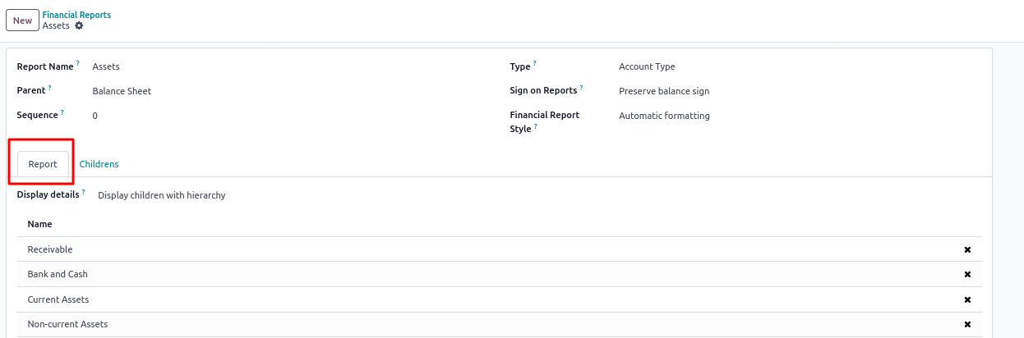

No Migrate : Payment - Providers, Methods, Tokens, Transaction, Follow-up
Tax Report

update account_analytic_plan set old_id = 2 where id = 1;

- Migrate : account_analytic_plan
  - Empty : account_analytic_applicability

UPDATE account_analytic_plan
SET name = jsonb_build_object(
'en_US',
REPLACE(name ->> 'en_US', '''', '"')::jsonb ->> 'en_US'
)
WHERE (name ->> 'en_US') LIKE '%''en_US''%';

<field name="complete_name" readonly="0"/>

elif old_table_name == 'account_analytic_account':
cursor.execute(f"SELECT {old_field_names} FROM {old_table_name} WHERE company_id = 2;")
rows = cursor.fetchall()

- Migrate : account_analytic_account
  - Skip : crossovered_budget_lines
  - Pending : bind invoice smart button

UPDATE account_analytic_account
SET name = jsonb_build_object(
'en_US',
REPLACE(name ->> 'en_US', '''', '"')::jsonb ->> 'en_US'
)
WHERE (name ->> 'en_US') LIKE '%''en_US''%';

elif old_table_name == 'account_analytic_line':
cursor_old.execute(f"SELECT {old_field_names} FROM {old_table_name} WHERE company_id = 2;")
rows = cursor_old.fetchall()

- Migrate : account_analytic_line

HR Expense

elif old_table_name == 'hr_expense':
cursor.execute(f"SELECT {old_field_names} FROM {old_table_name} WHERE company_id = 2;")
rows = cursor.fetchall()

- Migrate : hr_expense
  - Second time migrate select id, state

select sum(total_amount) from hr_expense

V15 hr_expense
state = fields.Selection([
('draft', 'To Submit'),
('reported', 'Submitted'),
('approved', 'Approved'),
('done', 'Paid'),
('refused', 'Refused')
], compute='_compute_state', string='Status', copy=False, index=True, readonly=True, store=True, default='draft', help="Status of the expense.")
V17 hr_expense
state = fields.Selection(
selection=[
('draft', 'To Report'),
('reported', 'To Submit'),
('submitted', 'Submitted'),
('approved', 'Approved'),
('done', 'Done'),
('refused', 'Refused')
],
string="Status", compute='_compute_state', store=True, readonly=True,
index=True, copy=False, default='draft',)

elif old_table_name == 'hr_expense_sheet':
cursor.execute(f"SELECT {old_field_names} FROM {old_table_name} WHERE company_id = 2;")
rows = cursor.fetchall()

- Migrate : hr_expense_sheet
  - Skipp : approval_state

- Hr_expense_sheet tree view name : hr.expense.sheet.tree

- For hr_expense_sheet , field - tax_ids, M2M table - expense_tax

Get Code Changes in def action_migrate_for_related_tables():

for row in rows:
old_expense_id, old_tax_id = row

# Get new hr_expense ID using old_id
cursor_current.execute("SELECT id FROM hr_expense WHERE old_id = %s", (old_expense_id,))
result = cursor_current.fetchone()
new_expense_id = result[0] if result else None

# Get new account_tax ID using old_id
cursor_current.execute("SELECT id FROM account_tax WHERE old_id = %s", (old_tax_id,))
result = cursor_current.fetchone()
new_tax_id = result[0] if result else None

# Skip if mapping fails
if not new_expense_id or not new_tax_id:
_logger.warning(f"Skipping: expense_id or tax_id not found for old_ids: {old_expense_id}, {old_tax_id}")
continue

# Check for existing entry to avoid duplicates
cursor_current.execute(
f"""
SELECT 1 FROM {current_table_name}
WHERE expense_id = %s AND tax_id = %s
""",
(new_expense_id, new_tax_id)
)
if cursor_current.fetchone():
_logger.info(f"Relation already exists for expense_id={new_expense_id}, tax_id={new_tax_id}. Skipping.")
continue

# Insert the relation
cursor_current.execute(
f"INSERT INTO {current_table_name} (expense_id, tax_id) VALUES (%s, %s)",
(new_expense_id, new_tax_id)
)
_logger.info(f"Inserted: expense_id={new_expense_id}, tax_id={new_tax_id}")

- Migrate : expense_tax
  - Select fields and click : “Migrate Related Table’s Fields” Button

For hr_expense and hr_expense_sheet Create Date: (Use Update Create Date button)

if old_table_name in [ 'hr_expense', 'hr_expense_sheet']:
cursor_old.execute(f"SELECT id, create_date FROM {old_table_name} WHERE company_id = 2;")
rows = cursor_old.fetchall()

if rows:
for old_id, create_date in rows:
# Update matching record in the current DB
cursor_current.execute(f"""
UPDATE {old_table_name}
SET create_date = %s
WHERE old_id = %s;
""", (create_date, old_id))

_logger.info(f"Updated : {old_table_name} , Old id : {old_id}, Total Record : {len(rows)}.")

conn_current.commit()

Step 7 : Accounting

update utm_medium set old_id = id;
update utm_source set old_id = id;
update utm_stage set old_id = id;
update utm_tag set old_id = id;

update account_incoterms set old_id = id;

update account_reconcile_model set old_id = 3 where id = 1;
update account_reconcile_model set old_id = 4 where id = 2;

payment_token is Empty table no need to migrate
account_cash_rounding is Empty table no need to migrate

account_bank_statement
- That has no data for Leviotto company.
- It means no need to migrate account_bank_statment_line
account.bank.statement.line
- The migration module does not show company id.

Migrate user 46
if old_table_name == 'res_users':
cursor_old.execute(f"SELECT {old_field_names} FROM {old_table_name} WHERE company_id = 2 or id In (6, 46);")
rows = cursor_old.fetchall()

Account Move

elif old_table_name == 'account_move':
cursor_old.execute(f"SELECT {old_field_names} FROM {old_table_name} WHERE company_id = 2;")
rows = cursor_old.fetchall()

Unarchive Journal : Car Promotion

- Migrate : account_move
  - First time migrate to select : id, name, journal_id, company_id, currency_id, state, date, auto_post, move_type (Match account move count)
  - Second time migrate to select : id, ref, journal_id, fiscal_position_id, invoice_user_id, team_id

  - No need (Move Lines) : asset_category_id, analytic_tag_ids, discount_amount, payment_transaction
  - Petty Cash, Petty Cash 159, Petty Cash Leviotto Shop (amount not match)
  - Time : 01:00

- Migrate : account_move [if state not valid]
  - state
  - Time: 01:00 for (state)

- Payments in invoices
  - Migrate account_move to select id and payment_id.
    - Verify record using this record - invoice : INV/2025/005937 check its payment : CSH1/2025/09/0051
    - INV/2023/00284

elif old_table_name == 'pdc_account_payment':
old_journal_ids = self.env['account.journal'].search([]).mapped('old_id') # already filtered by company earlier
if old_journal_ids:
journal_ids_tuple = tuple(old_journal_ids)
query = f"SELECT {old_field_names} FROM {old_table_name} WHERE journal_id IN %s"
cursor.execute(query, (journal_ids_tuple,))
rows = cursor.fetchall()
else:
rows = []

- Migrate : pdc_account_payment
  - First Migrate : normal field use
  - Second Time Migrate Select : Id, invoice_ids M2M (Click Migrate Relational Fields Button)

elif old_table_name == 'account_payment':
old_move_ids = self.env['account.move'].search([]).mapped('old_id') # already filtered by company earlier
if old_move_ids:
move_ids_tuple = tuple(old_move_ids)
query = f"SELECT {old_field_names} FROM {old_table_name} WHERE move_id IN %s"
cursor_old.execute(query, (move_ids_tuple,))
rows = cursor_old.fetchall()
else:
rows = []

- Migrate : account_payment
  - The migration module does not show company id, that's why use move_id, must be selected every time when migrate account_payment.

- Amount_company_currency_signed not matched in payments
  - In account_payment select id and amount_company_currency_signed , migrate it.

elif old_table_name == 'account_move_line':
cursor_old.execute(f"SELECT {old_field_names} FROM {old_table_name} WHERE company_id = 2;")
rows = cursor_old.fetchall()

- Migrate : account_move_line
  - 'analytic_distribution': {'4': 100} [Error during migration: can't adapt type 'dict']
    - UPDATE account_move_line
    - SET analytic_distribution = '{"7": 100}'
    - WHERE old_id = 598990;
  - Time : 04:00

- Amount in currency and currency not set in list view - Journal Items
  - In account_move_line select amount_currency and currency_id
    - Holde : its not show only list view, but when open a record its show values.

- Originator PDC payments not set in journal items
  - In account_move_line select id and payment_pdc_id
  - Using this record to verify originator pdc payment : BNK2/2025/11/0001

if current_table_name == "account_move_line_account_tax_rel":
# Fetch specific company data from old database
cursor_old.execute(f"""
SELECT {old_field_names}
FROM {old_table_name} rel
JOIN account_move_line aml ON aml.id = rel.account_move_line_id
WHERE aml.company_id = 2;
""")
rows = cursor_old.fetchall()

for row in rows:
old_move_line_id, old_tax_id = row

# Get new account.move.line ID using old_id
cursor_current.execute("SELECT id FROM account_move_line WHERE old_id = %s", (old_move_line_id,))
result = cursor_current.fetchone()
new_move_line_id = result[0] if result else None

# Get new account.tax ID using old_id
cursor_current.execute("SELECT id FROM account_tax WHERE old_id = %s", (old_tax_id,))
result = cursor_current.fetchone()
new_tax_id = result[0] if result else None

# Skip if mapping fails
if not new_move_line_id or not new_tax_id:
_logger.warning(
f"Skipping row: account_move_line_id or account_tax_id not found for old_ids: {old_move_line_id}, {old_tax_id}"
)
continue

# Check for existing record to avoid duplicates
cursor_current.execute(
"""
SELECT 1 FROM account_move_line_account_tax_rel
WHERE account_move_line_id = %s AND account_tax_id = %s
""",
(new_move_line_id, new_tax_id)
)
if cursor_current.fetchone():
_logger.info(
f"Relation already exists for account_move_line_id={new_move_line_id}, account_tax_id={new_tax_id}. Skipping."
)
continue

# Insert the new relation
cursor_current.execute(
"""
INSERT INTO account_move_line_account_tax_rel (account_move_line_id, account_tax_id)
VALUES (%s, %s)
""",
(new_move_line_id, new_tax_id)
)
_logger.info(
f"Inserted relation: account_move_line_id={new_move_line_id}, account_tax_id={new_tax_id}"
)

- Migrate : account_move_line_account_tax_rel M2M
  - Select both fields : account_move_line_id, account_tax_id
  - Click : Migrate Related Table Fields Button
  - Time : 00:35 for (tax_ids)

elif current_table_name == "account_account_tag_account_move_line_rel":
# Fetch specific company data from old database
cursor_old.execute(f"""
SELECT {old_field_names}
FROM {old_table_name} rel
JOIN account_move_line aml ON aml.id = rel.account_move_line_id
WHERE aml.company_id = 2;
""")
rows = cursor_old.fetchall()

for row in rows:
# Assuming row contains old_move_line_id and old_tag_id from old DB
old_move_line_id, old_tag_id = row

# Get new account.move.line ID using old_id
cursor_current.execute("SELECT id FROM account_move_line WHERE old_id = %s", (old_move_line_id,))
result = cursor_current.fetchone()
new_move_line_id = result[0] if result else None

# Get new account.account.tag ID using old_id
cursor_current.execute("SELECT id FROM account_account_tag WHERE old_id = %s", (old_tag_id,))
result = cursor_current.fetchone()
new_tag_id = result[0] if result else None

# Skip if mapping fails
if not new_move_line_id or not new_tag_id:
_logger.warning(
f"Skipping row: account_move_line_id or account_account_tag_id not found for old_ids: {old_move_line_id}, {old_tag_id}"
)
continue

# Check for existing record to avoid duplicates
cursor_current.execute(
"""
SELECT 1 FROM account_account_tag_account_move_line_rel
WHERE account_move_line_id = %s AND account_account_tag_id = %s
""",
(new_move_line_id, new_tag_id)
)
if cursor_current.fetchone():
_logger.info(
f"Relation already exists for account_move_line_id={new_move_line_id}, account_account_tag_id={new_tag_id}. Skipping."
)
continue

# Insert the new relation
cursor_current.execute(
"""
INSERT INTO account_account_tag_account_move_line_rel (account_move_line_id, account_account_tag_id)
VALUES (%s, %s)
""",
(new_move_line_id, new_tag_id)
)
_logger.info(
f"Inserted relation: account_move_line_id={new_move_line_id}, account_account_tag_id={new_tag_id}"
)

- Migrate : account_account_tag_account_move_line_rel M2M
  - Select both fields : account_move_line_id, account_account_tag_id
  - Click : Migrate Related Table Fields Button
  - Time : 00:30 for (tax_tag_ids)

Record for verify value of tex tag ids, tax ids of account move line : RINV/2025/00224

elif old_table_name == 'account_partial_reconcile':
cursor.execute(f"SELECT {old_field_names} FROM {old_table_name} WHERE company_id = 2;")
rows = cursor.fetchall()

- Migrate : account_partial_reconcile
  - After migrate it : Bind Invoice and Bill of Account Payment.

- Migrate : account_full_reconcile

BNK2/2025/11/0001 check reconcile enter

Step 8 : Configuration

Set Company Properties of :
property_account_receivable_id (account.account,688)
property_account_payable_id (account.account,1138)

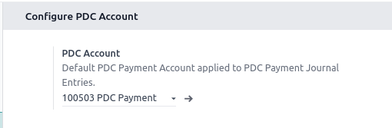
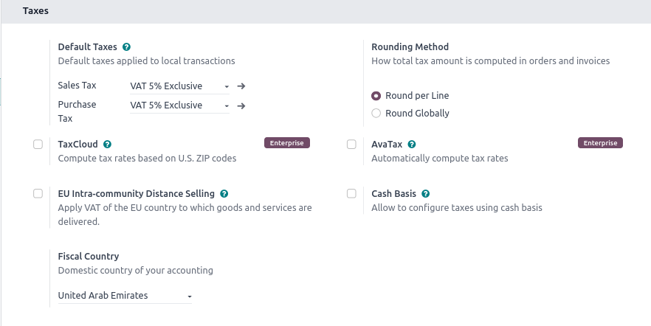
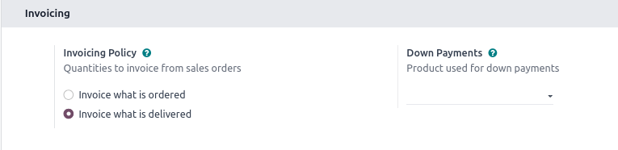

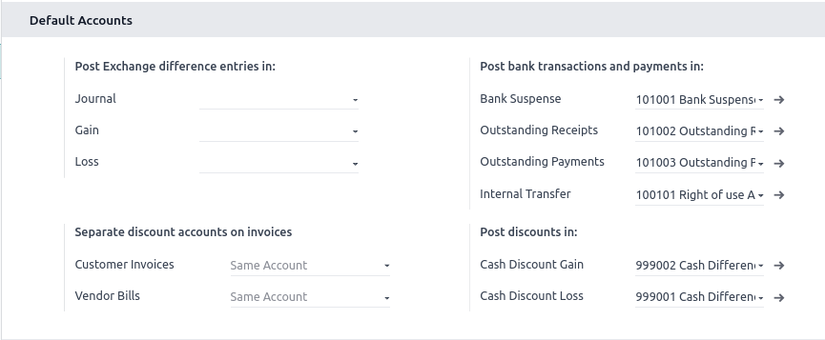

- User assess Check

- In sale order line when open packages not show available qty and size : Run compute for both
  - result = []
  - packages = self.env['stock.quant.package'].search([])
  - packages._compute_available_qty()

- Set allowed companies in all users
  - Visible company_ids in user form view and add leviotto company of all users.

- Customer payment terms and vendor payment terms in contacts
- Fiscal Position in contacts
- Product Cost and Sale Price
- Product Responsible Person
  - Using Excel file script to migrate it

- Brand in products
  - In Migration Module search “as_product_brand”
  - And in Current database table select “Product Brand”
  - And migrate it then migrate product template relation m2o field of product brand.

UPDATE product_brand
SET name = jsonb_build_object(
'en_US',
REPLACE(name ->> 'en_US', '''', '"')::jsonb ->> 'en_US'
)
WHERE (name ->> 'en_US') LIKE '%''en_US''%';

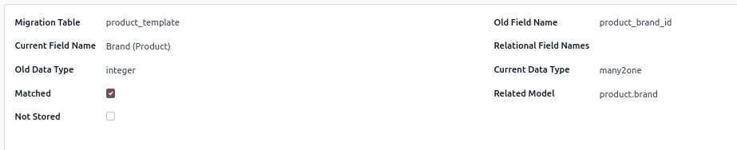

- Journal - Car Promotion
  - not in 15 (It is there in 15 but in database not displayed in front)

- Vendor PDC payments
  - Vendor pdc payments get by journal.
  - Mashreq Bank (14), Rak Bank (25) : Leviotto
  - Bank (44) : Dazzle

- Expense total amount not matched
  - In hr_expense select id and total_amount : migrate it
- Expense report count and total_amount not matched

- Check Creation date
  - hr_expense, hr_expense_sheet, hr_employee, product_template,
  - Using update create date button : no need to select specific field, open table and migrate it.
  - In Contacts apply create date filter and show current date partner it is extra partners, delete it.

- Physical Inventory - On hand stock is matched but quants count not matched
- Pending package transfer smart button
- Migrate : account_analytic_account
  - Pending : bind invoice smart button
  - Pending : Gross Margin button not show amount, but bind the record

Step 9 : Extra Record Delete
- Add filter group by company and created on
- Verify and delete extra records.

- product_template

account.root
account.cash.rounding
account.asset.depreciation.line
account.asset.asset
account.asset.category
account.analytic.line
account.report

Python 3.8

appdirs 1.4.4
attrs 25.3.0
Babel 2.9.1
bcrypt 5.0.0
beautifulsoup4 4.14.2
cached-property 2.0.1
certifi 2025.10.5
cffi 1.17.1
chardet 3.0.4
cryptography 38.0.4
decorator 4.4.2
defusedxml 0.7.1
docutils 0.16
ebaysdk 2.1.5
freezegun 0.3.15
gevent 20.9.0
greenlet 0.4.17
idna 2.8
isodate 0.7.2
Jinja2 2.11.3
libsass 0.18.0
lxml 4.6.5
MarkupSafe 1.1.0
num2words 0.5.6
ofxparse 0.19
paramiko 3.5.1
passlib 1.7.3
Pillow 9.0.1
pip 25.0.1
polib 1.1.0
psutil 5.6.7
psycopg2 2.8.6
psycopg2-binary 2.9.10
pyasn1 0.6.1
pyasn1_modules 0.4.2
pycparser 2.23
pydot 1.4.1
PyNaCl 1.6.0
pyOpenSSL 22.1.0
pyparsing 3.1.4
PyPDF2 1.26.0
pyserial 3.4
python-dateutil 2.7.3
python-ldap 3.4.0
python-stdnum 1.13
pytz 2019.3
pyusb 1.0.2
qrcode 6.1
reportlab 3.5.59
requests 2.25.1
requests-toolbelt 1.0.0
setuptools 75.3.2
six 1.17.0
soupsieve 2.7
typing_extensions 4.13.2
urllib3 1.26.5
vobject 0.9.6.1
Werkzeug 0.16.1
wheel 0.45.1
xlrd 1.2.0
XlsxWriter 1.1.2
xlwt 1.3.0
zeep 3.4.0
zope.event 5.0
zope.interface 7.2

python3 /home/sandip/Desktop/Projects/Thamees_Base/Contact_Payment_Term.py

Upgraded Database Converter
- https://upgrade.odoo.com/
- M23010466223774
- Nov 1 2025 - 05:35

